import tensorflow as tf import matplotlib as plt import numpy as np import keras

mnistDB=tf.keras.datasets.mnist

#Splitting The Data (X_train,Y_train),(X_test,Y_test)=mnistDB.load_data() X_train=X_train.reshape(60000,28,28,1) X_test=X_test.reshape(10000,28,28,1)

#Data Normalisation X_train=X_train.astype('float32')/255 X_test=X_test.astype('float32')/255

#Defining the model

ML=keras.models.Sequential() ML.add(keras.layers.Conv2D(32,(3,3),activation="relu",input_shape=X_train.shape[1:])) ML.add(keras.layers.Conv2D(64,(3,3),activation="relu")) ML.add(keras.layers.MaxPooling2D((2,2)))

ML.add(keras.layers.Dropout(0.25)) ML.add(keras.layers.Flatten()) ML.add(keras.layers.Dense(128,activation='relu'))

ML.add(keras.layers.Dropout(0.25)) ML.add(keras.layers.Dense(units=10,activation="softmax")) ML.compile(loss="sparse_categorical_crossentropy",optimizer="adam",metrics=['Accuracy'])

ML.summary() #Training the data

history=ML.fit(X_train,Y_train,epochs=2,batch_size=16)

ML.evaluate(X_test,Y_test)

print("Evaluating the model:", ML.evaluate(X_test,Y_test))

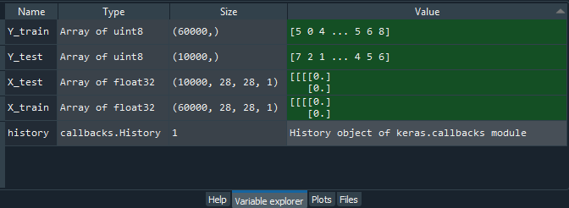

In [**34**]: runfile('C:/Users/user/.spyder-py3/autosave/untitled3.py', wdir='C:/Users/user/.spyder-py3/autosave') Reloaded modules: tmp4tt9be3h

Model: "sequential_13"

Layer (type) Output Shape Param #

=================================================================

|  |  |  |
| --- | --- | --- |
| conv2d_24 (Conv2D) | (None, 26, 26, 32) | 320 |
| conv2d_25 (Conv2D) | (None, 24, 24, 64) | 18496 |
| max_pooling2d_16 (MaxPooling (None, 12, 12, 64) 0 | | |
| dropout_23 (Dropout) | (None, 12, 12, 64) | 0 |
| flatten_11 (Flatten) | (None, 9216) | 0 |
| dense_21 (Dense) | (None, 128) | 1179776 |
| dropout_24 (Dropout) | (None, 128) | 0 |
| dense_22 (Dense) | (None, 10) | 1290 |

=================================================================

Total params: 1,199,882

Trainable params: 1,199,882

Non-trainable params: 0

Epoch 1/2

3750/3750 [==============================] - 178s 44ms/step - loss: 0.1303 - Accuracy: 0.9602

Epoch 2/2

3750/3750 [==============================] - 192s 51ms/step - loss: 0.0542 - Accuracy: 0.9830

313/313 [==============================] - 8s 23ms/step - loss: 0.0345 - Accuracy: 0.9889

313/313 [==============================] - 7s 23ms/step - loss: 0.0345 - Accuracy: 0.9889 Evaluating the model: [0.03451981022953987, 0.9889000058174133]

In [**35**]: